Groundcrew.AI Stage 5
1. On the “Topics” tab in your agent building page, create “+ Add a topic” under custom topics and choose “From blank”

2. In the topic builder, describe the topic as you wish, or use this description
“This topic allows user to input their email and verify it using an auto generated OTP”
3. Below the trigger node, add a “Ask with adaptive card” node
4. Click on the three Dotson the adaptive card node and click on properties, then select “Edit adaptive card”. You will be brough to this page.
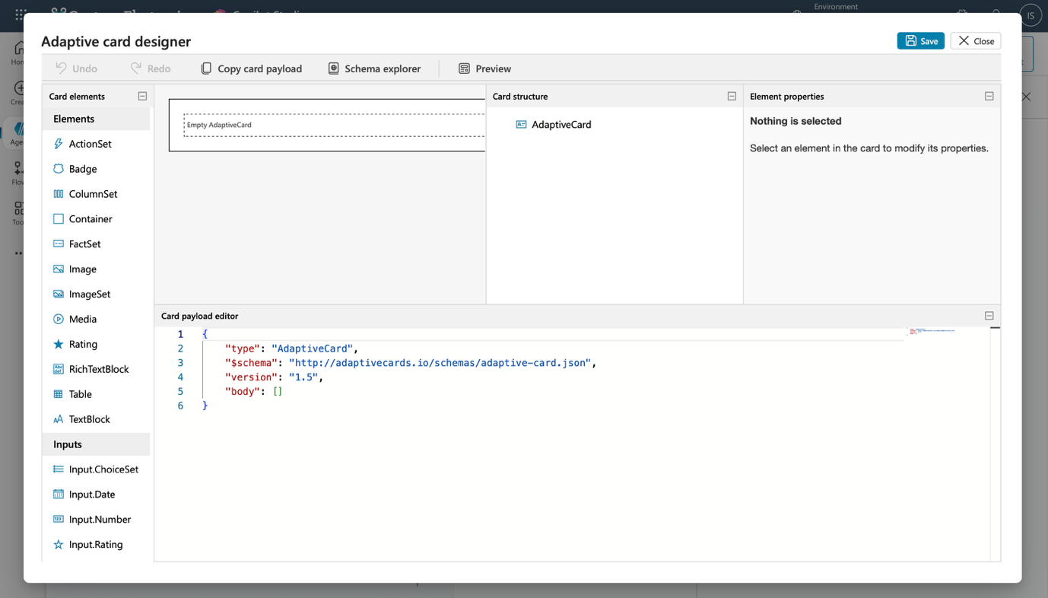
5. On the adaptive card editor, paste this code
{
"$schema": "http://adaptivecards.io/schemas/adaptive-card.json",
"type": "AdaptiveCard",
"version": "1.5",
"body": [
{
"type": "Container",
"style": "emphasis",
"bleed": true,
"items": [
{
"type": "TextBlock",
"text": "✨ Verify Your Identity",
"weight": "Bolder",
"size": "Large",
"color": "Accent",
"horizontalAlignment": "Center"
},
{
"type": "TextBlock",
"text": "Enter your details below to generate your OTP 🔐",
"wrap": true,
"spacing": "Small",
"horizontalAlignment": "Center"
}
]
},
{
"type": "Container",
"style": "default",
"items": [
{
"type": "TextBlock",
"text": "👤 Full Name",
"weight": "Bolder",
"spacing": "Medium"
},
{
"type": "Input.Text",
"id": "username",
"placeholder": "Your full name"
},
{
"type": "TextBlock",
"text": "📧 Email Address",
"weight": "Bolder",
"spacing": "Medium"
},
{
"type": "Input.Text",
"id": "useremail",
"placeholder": "example@company.com",
"style": "Email"
}
],
"bleed": true
}
],
"actions": [
{
"type": "Action.Submit",
"title": "Generate OTP 🔐",
"data": {
"action": "generateOtp"
}
}
]
}
6. Click save and exit and you should see a nice adaptive card with 4 outputs!
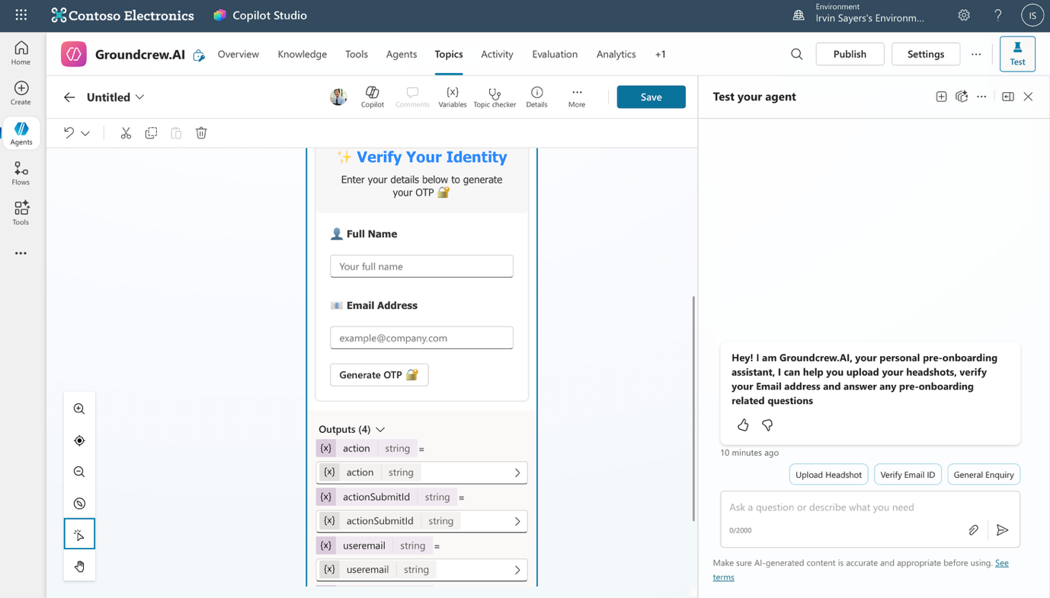

7. Rename the topic to “Verify email” on the top left instead of untitled. Then click save. Congratulation! You just created a topic with an adaptive card, let’s create a flow to generate the OTP next, move to the next step whenever you are ready!

